COMMUNITY WELLNESS COUNCIL
100% Community
Policy and Procedure

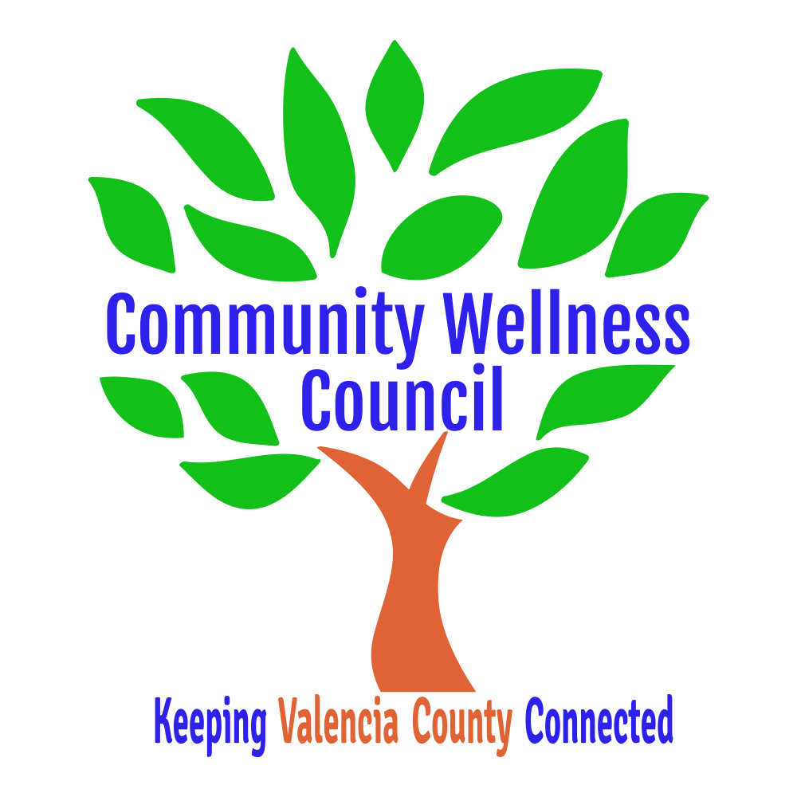

Our Vision:
(CWC) A community working in cooperation to ensure the health and well-being of all its residents."
(100% Community); All residents are healthy, safe and resilient.
Our Core Values: Determine with Core team at first meeting:
- Open communication clear expectations
- Diversity Equity and Inclusion
- Community Voice, Partnership and Leadership
- Instilling Community Ownership
- Bi-Directional Feedback – Co-Learning
Our Mission:
CWC: To promote community collaboration through a framework of coordination, assessment and solutions.
Framework and strategy implemented at county level to align actions and strengthen communication between state, county and city leaders. Ensure 10 vital services by empowering all local governmental and non-governmental agencies leaders within a county : Food, Housing, Medical Care, Behavioral Health, Parenting Supports, Early Childhood, Community Schools, Jobs, Transportation, Youth Mentoring (cite these)

Section I. About Community Wellness Council
A Guide to CWC Acronyms:
CWC = Community Wellness Council AA8 = Anna, Age 8
ACEs = Adverse Childhood Experiences

- Organization Overview
History of Council
The Community Wellness Council originated in 1993 as the Valencia County Coalition for Families, Children and Community (VCC-FCC), and was “…dedicated to helping build better futures for children and families in Valencia County.” The Valencia Maternal Child Health (MCH) Council served in an advisory capacity to the VCC-FCC. In 1999 the VCC-FCC was reorganized as the Valencia Community Partnership, transitioning from a service organization to a focused health assessment and planning organization.
In 2010 the council once again reorganized to become the Community Wellness Council with the mission to promote community collaboration through a framework of coordination, assessment and solutions. Through its many transitions and iterations the Council has retained its 501©3 status and an active and dedicated leadership team passionate about community wellness, health and safety. In addition, the Community Wellness Council continues to maintain a mutually beneficial relationship with the New Mexico Alliance of Health Councils which includes Tribal partners.
Measuring Success
The Council focuses its work on a wide variety of issues including: wellness, health equity, injury prevention, and health promotion. On-going council-sponsored assessments will provide county stakeholders and other residents with data on both community problems and how collaboration and cooperation are addressing effectively addressing them.

Priorities & Partnerships
The Council is working to become an information hub in which a framework is used to assess the on-going needs in Valencia County, and by meeting identified needs through the promotion of collaboration between agencies, coalitions, and action groups. Our partnering agencies and organizations include local coalitions, governmental bodies, schools, nonprofit organizations, civic groups, and service agencies. The Council is currently conducting an assessment of the diverse community groups that are active in the county.
- Code of Conduct
• Keep your remarks pertinent to the audience and topic at hand.
• Be mindful of the time and give everyone a chance to speak.
• As a strategy to encourage a community participation, we suggest focusing on the positive solutioning while addressing community concerns.
• Use language that is generally perceived to be inclusive, family-friendly, that helps build communities and does not cause any harm including breaking confidentiality.
• Be receptive to CWC board member feedback.
• Be mindful of our multicultural communities and therefore we suggest refraining from religious practices as part of your task force meetings.
• Refrain from political campaigning.
In the case of conflict, please address the person(s) involved, the task force chair, the core team or the CWC board chair in that order if resolution is not found at the lowest level of intervention.
If there are procedural questions that arise and are not addressed here, the CWC bylaws could pertain until further guidance is voted on.

Section II. 100% Community Structure

Community Wellness Council Board

100% Community Core Team

Task Force Chairs

Task Force Members

Food
Parenting

Housing
Early Childhood

Transportation
Mentoring

Medical/Dental
Community Schools

Behavioral Health
Jobs

Section III. Role of the 100% Community Task Force Chairs and Members

- General.
  - The Task Forces year runs from July 1 to June 30, in conjunction with CWC fiscal year.
  - In order for the Task Forces to operate properly, Chairs and the Core Team need to act as a unified team and continually communicate with one another. As such, it is expected that all communication and notice of meetings be inclusive, professional, timely, and courteous.
  - Core Team and Task Forces will follow the 100% Community initiative framework as outlined in the book by the same title.
- Core Team:
  - Core Team shall consist of 2 CWC Board Members, and 3 other community stakeholders chosen by the CWC Board and represent the whole county generally speaking.
  - Core Team members will meet monthly either in person or via electronic means to provide guidance and support to the Task Force Chairs and to assess progress towards the goals of 100% Community.
- Task Force Chairs, Vice Chairs, and Secretary
  - Each Task Force will consist of one Task Force Chair, Vice Chair, Secretary, and unlimited additional members.
  - Candidates for Task Force Chair and Vice Chair is anyone who is passionate about the work and is willing to review their task force chapter in 100% Community. Candidates will submit a letter of interest outlining skill sets, commitment and availability. Chairs will be confirmed by the Core Team.
  - Candidates for Secretary can be a volunteer member who is committed to taking accurate minutes and sending them out to the Task Force Chair each month.
  - Candidates for participation can be, but are not limited to, people working in the field, are passionate about making change, those looking to learn more and get involved.
  - Task Force Chairs and Vice Chairs can expect to commit 30 to 40 hours per year. With general members committing to approximately 35 hours.
  - Task Force Chairs and Vice Chairs will prepare all public presentations ahead of time and provide these to the Core Team for approval. Task Force Chairs will make sure that Task Force Members also not represent 100% Community in public forums including discussions with elected officials and governmental agencies without first obtaining approvals.
  - Task Force Chairs and Vice Chairs should ensure that Task Force members are clear with community as to which hat they are wearing when engaging on behalf of 100% Community.
  - The Task Force Chairs and Vice Chairs shall contact new or prospective members and provide them with enough information to get started and will add them to their email list.
  - Email: Task Force Chairs and Vice Chairs will maintain and update the email list in the account provided by CWC and ensure the security of that information. All emails to the group shall by also sent to the Core Team.
  - Each Task Force Chair and Vice Chairs shall serve for a term of one year and will attend 21 out of 24 meetings per year.
  - After one year, the majority vote of the general membership of that task force can recommend renewal to the Core Team
- Majority vote of members in attendance shall constitute approval. Meetings.
  - Each task force will meet as least monthly but more as needed.
  - Task Force Chairs are expected to report their activities monthly to the Core Team during the second half of the Core Team meeting.
  - Members may attend meetings in person or via electronic communications (meeting software, e.g. Teams or Zoom or telephone) which allow all persons participating in the meeting to communicate with each other at the same time.
  - Meetings location will be decided by the Task Force Chair in conjunction with their general membership.
  - Each general member has one vote.
  - Meeting minutes should be taken at every task force meeting and can be available to the public. Best practice is to inform meeting attendees at the beginning of the meeting that the minutes are public.
  - Action Items lists should be sent out as soon as possible after every meeting (within a week)
- General Task Force Members: Besides preparing for and actively participating in meetings, all members are expected to (within their ability):
  - Actively participate in innovation projects from 100% Community or other supporting projects.
  - Assist in developing solutions.
  - Work in collaboration with the community.
  - Act on Action Items that they have agreed to as soon as possible.
  - Take care in representing 100% Community Initiative and only present in public forums with approval of one’s task force AND the Core Team.
  - Be open to adjustments as things develop and feedback on strategies.
- Revisions: The Core Team is responsible for reviewing this document annually by June 30th and taking it to the CWC for approval. The Core Team must provide an updated version to task force chairs within 30 days of approval from the CWC board.

